Scenario 6: There is a user who is fascinated using aws via CLI. He is bored of login into console and navigating.
He asked that he need to access the AWS resources from his machine via CLI.
- yes, we can do it by creating an Access secret.
- Before that user needs to download the AWS CLI
- https://docs.aws.amazon.com/cli/latest/userguide/getting-started-install.html
- This link contains the steps and package to install the application on Windows, Linux and Mac OS.
TO create access keys.
Step 1: login to IAM console > locate the user account who needs access keys.
Step 2: click on create access key.
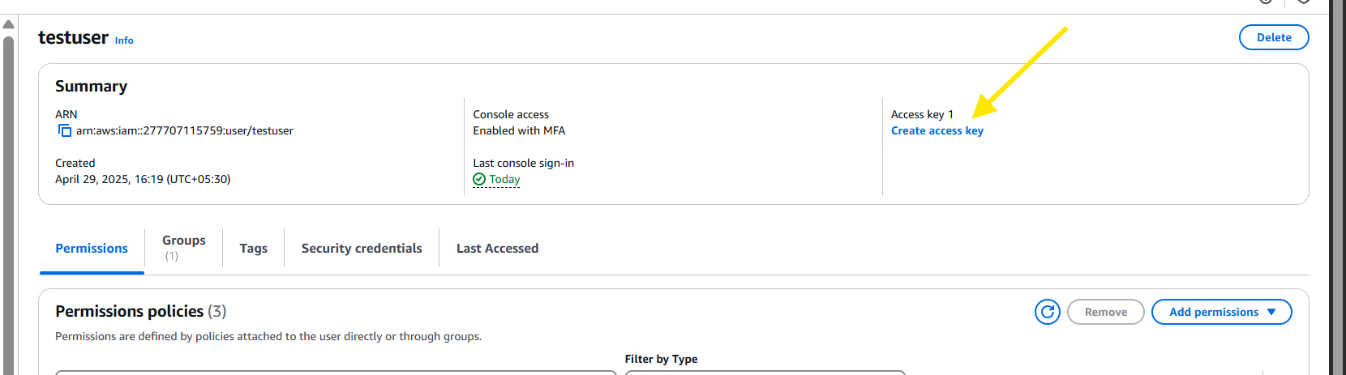
Step 3: Select CLI
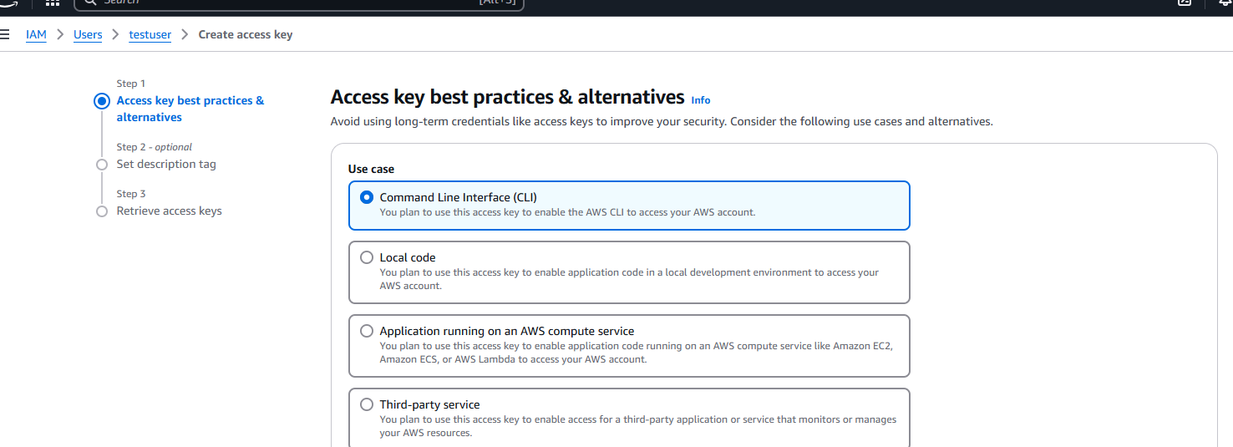
Step 4: Optional, you can enter the description
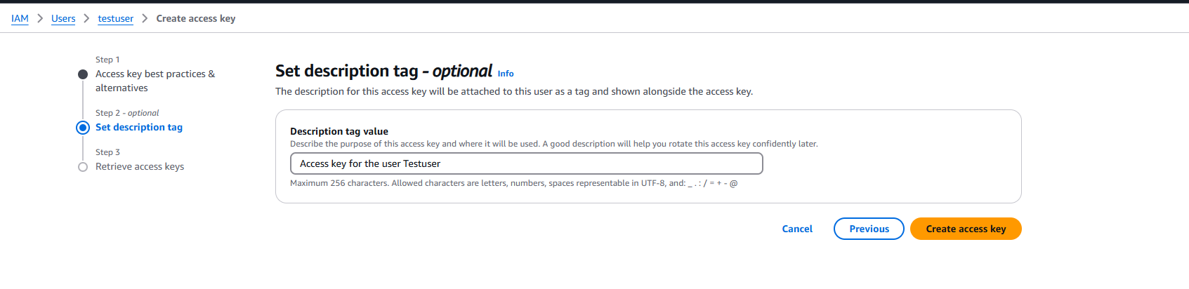
Step 5: Note: make sure to copy the access keys because it cannot be recovered.
Once copied you can provide it to the users.
